Create a tomcat.service File for Apache Tomcat
Here is the solution.

Step-by-Step Fix
- Start your Ubuntu VM.
- Open a Terminal (Ctrl + Alt + T).
- Create the Tomcat Service File:
Run the following command to create the service file:
sudo nano /etc/systemd/system/tomcat.service
- Add the Tomcat Service Configuration:
Copy and paste the following configuration into the file. This example assumes Tomcat is installed in /opt/tomcat and runs as the tomcat user.
[Unit]
Description=Apache Tomcat Web Application Server
After=network.target

[Service]
Type=forking

User=tomcat
Group=tomcat

Environment="JAVA_HOME=/usr/lib/jvm/java-21-openjdk-amd64"
Environment="CATALINA_HOME=/opt/tomcat"
Environment="CATALINA_BASE=/opt/tomcat"
Environment="CATALINA_PID=/opt/tomcat/temp/tomcat.pid"

ExecStart=/opt/tomcat/bin/startup.sh
ExecStop=/opt/tomcat/bin/shutdown.sh

Restart=on-failure

[Install]
WantedBy=multi-user.target
Note: Adjust JAVA_HOME to match your installed Java version and CATALINA_HOME to match your actual Tomcat installation directory.
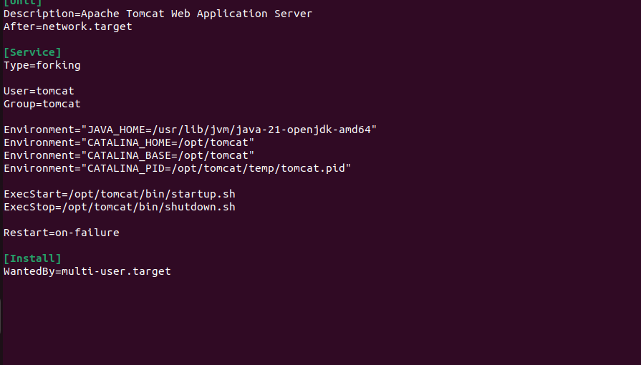
- Save and Exit the File:
  - Press Ctrl + O to save.
  - Press Enter to confirm.
  - Press Ctrl + X to exit.
- Reload the Systemd Manager:
Run:
sudo systemctl daemon-reload
This makes systemd recognize the new Tomcat service file.
- Enable the Tomcat Service:
Run:
sudo systemctl enable tomcat
This configures Tomcat to start automatically when Ubuntu boots.
- Start the Tomcat Service:
Run:
sudo systemctl start tomcat
- Check the Service Status:
Run:
sudo systemctl status tomcat
If the configuration is correct, the service should show active (running).
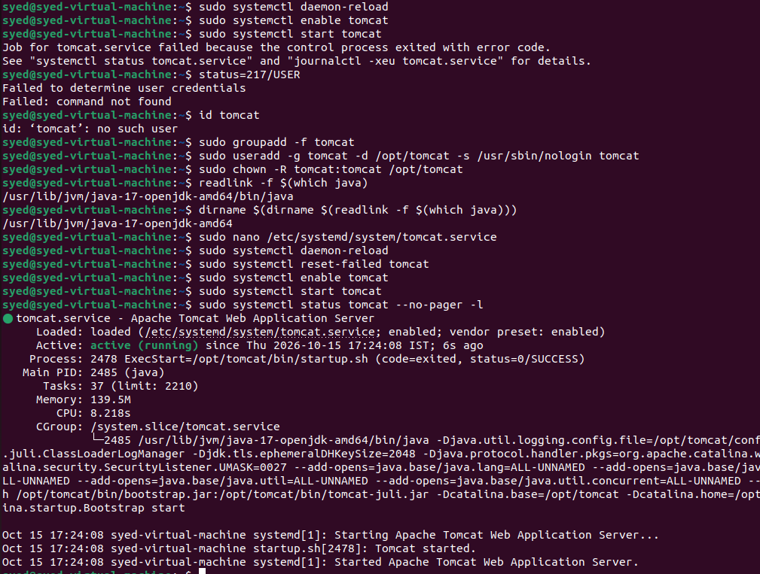
- Test Tomcat in the Browser:
Open Firefox in Ubuntu and enter:
http://localhost:8080
If Tomcat is configured to use port 8082, enter http://localhost:8082 instead.
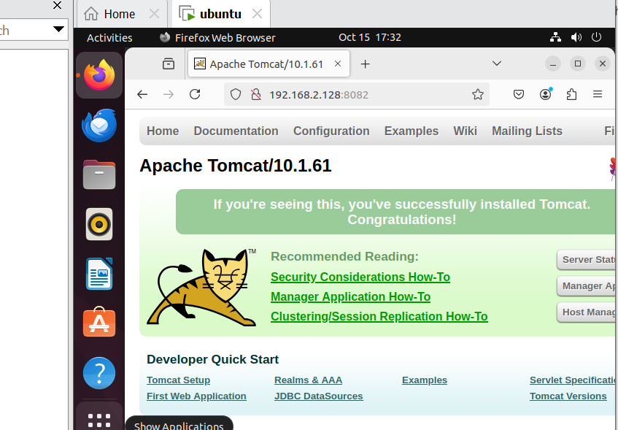
- Troubleshoot if Tomcat Does Not Start:
Run:
sudo journalctl -u tomcat -n 50 --no-pager
This displays recent Tomcat service logs to help identify errors.

